Joe Kay, founder of Soulection (Photo credit: Juan Medina @juansvisuals)

The Sound of Tomorrow Powered by the Future of Audio
Music collective Soulection and audio company Sennheiser announce partnership as Soulection enters its 15th anniversary

Wedemark/Los Angeles, January 27, 2026 – Following the official 15th birthday of music collective Soulection on January 24th, which was celebrated with a 15-hour takeover of the iconic Club Space Miami, Soulection and Sennheiser have announced a partnership that will see the two brands collaborate during the entire milestone birthday year and beyond. The Soulection community can look forward to a year stacked with dynamic music and events in different locations around the globe, supported by Sennheiser tools for both creation and playout.

Founded by global DJ and entrepreneur Joe Kay in 2011, Soulection has evolved into a globally recognized music collective, record label, radio platform and creative community. With a focus on music discovery, Los Angeles-based Soulection has a deeply loyal audience, especially among next-gen DJs, producers, creators and tastemakers in the US, UK and Europe, who tune in to the weekly two-hour Soulection Radio show on Apple Music 1 broadcasted worldwide.



“For me, Soulection and Sennheiser are a perfect fit,” says Itamar Marom, Brand Partnerships Manager at Sennheiser. “Soulection has played a defining role in the curation of music, artist discovery, and shaping the future of music culture, while Sennheiser has spent more than 80 years enabling artists and engineers with professional audio tools that define how music is recorded, performed, and experienced today. We are very much looking forward to celebrating the 2026 anniversary year with the collective, supporting audio workflows and events along the way.”

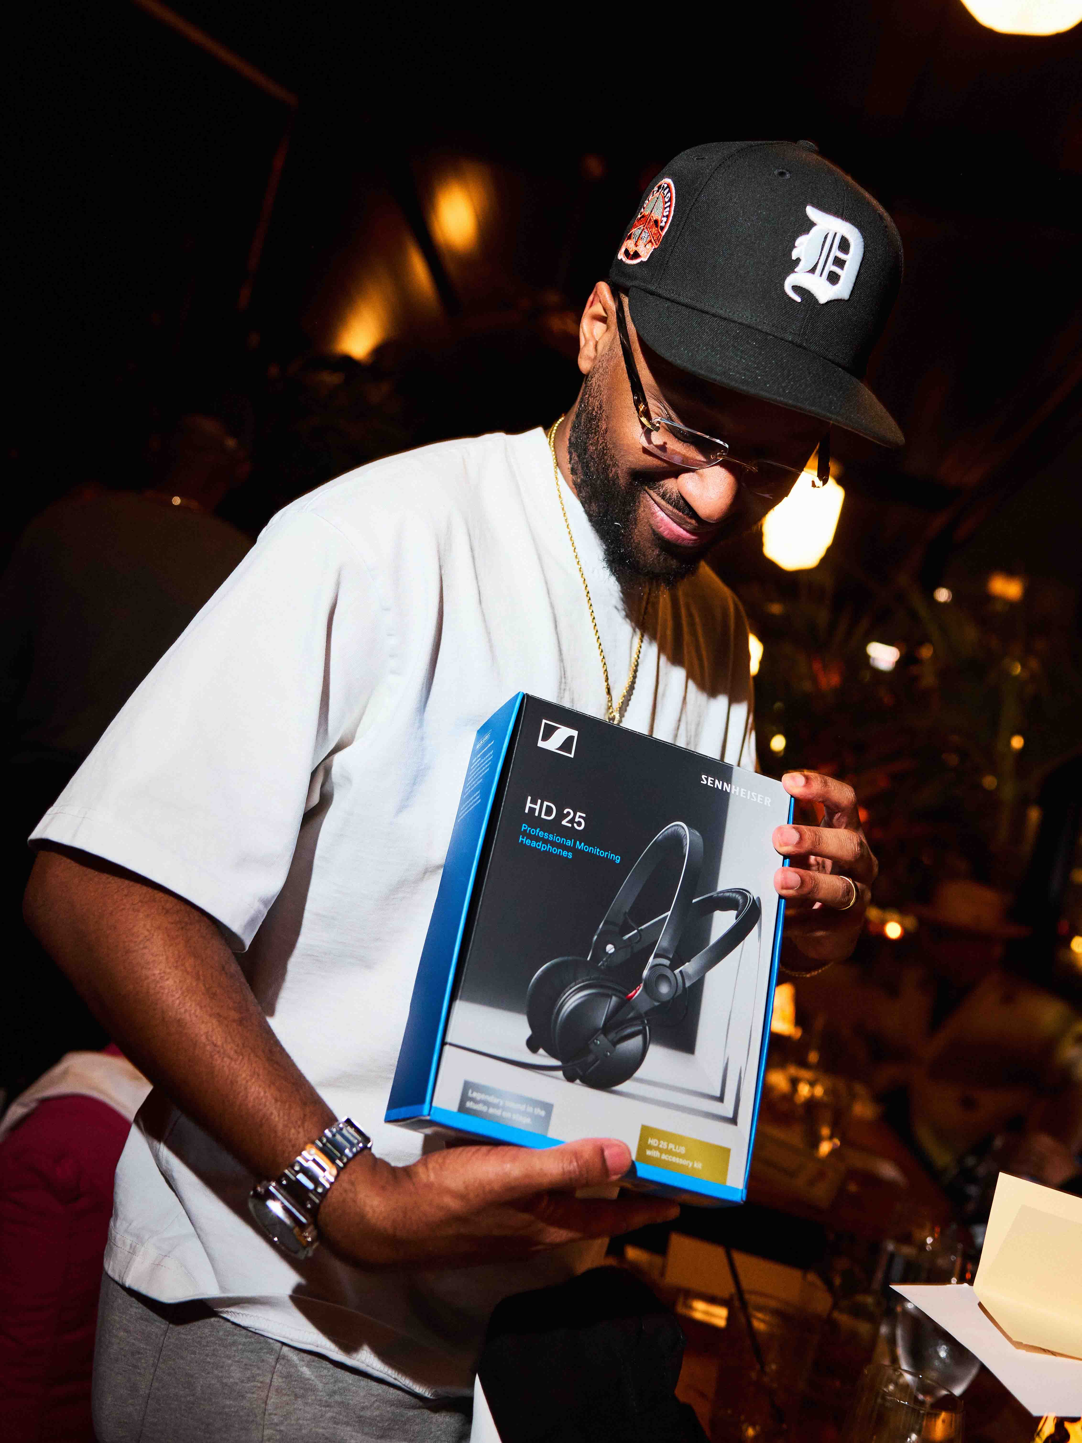 | Producer and DJ Sango at the 15th anniversary celebration (Photo credit: Juan Medina @juansvisuals)

“Over the years, Sennheiser has been my go-to headphones. Whether I am playing live, recording Soulection Radio, or digging for new music, their headphones have always been how I connect to the sound. The clarity, the detail, the trust I have in what I am hearing - that is everything to me as a DJ and curator,” says Joe Kay, Soulection Founder. “So partnering with Sennheiser as Soulection celebrates 15 years is not a coincidence. It is alignment. We love partnering with brands that share the same commitment to excellence, and Sennheiser has earned that place. I am excited for what we are building together and for everything to come in 2026 and beyond.”

Soulection and Sennheiser have planned a year-long celebration across key cultural events in Miami, London and Los Angeles - stay tuned for more partnership news during 2026.

(Ends)

The high-resolution images accompanying this media release plus additional photos can be downloaded here.

About Soulection
Soulection is a Los Angeles-based music platform and community that was established in 2011 by DJ, artist, and cultural curator Joe Kay. It functions as an independent record label, a global music discovery and curation platform, and a lifestyle brand. Soulection is known for its weekly radio show on Apple Music 1, its curated events, and its clothing line, all while promoting a “borderless, genre-bending musical movement.”
Follow Soulection: Instagram / TikTok / X / YouTube /

About the Sennheiser brand
We live and breathe audio. We are driven by the passion to create audio solutions that make a difference. Building the future of audio and bringing remarkable sound experiences to our customers – this is what the Sennheiser brand has represented for 80 years. While professional audio solutions such as microphones, meeting solutions, streaming technologies and monitoring systems are part of the business of Sennheiser electronic SE & Co. KG, the business with consumer devices such as headphones, soundbars and speech-enhanced hearables is operated by Sonova Holding AG under the license of Sennheiser.

www.sennheiser.com
www.sennheiser-hearing.com

